# OVERVIEW OF MINI PROJECT

In order to provide users with a complete login and to-do list management system, this project mixes frontend development using Tkinter with backend database management with MySQL. Users interact with user- friendly interfaces for task management, registration, and login by utilizing Tkinter's GUI features. MySQL manages user credentials and job information behind the scenes, securely storing and retrieving them to protect user privacy and data integrity. Through smooth navigation, real- time task updates, and strong error handling, this integration gives users powerful capabilities that make it an adaptable option for managing projects and organizing personal tasks.

## COMPONENTS OF THE APPLICATION:

Registering And Logging In:

With their password and username, users can log in. They can go to the registration page if they haven't already registered

To register, you need to provide your username, email address, phone number, password, and password confirmation. Before permitting registration, it verifies that the passwords match.

To-Do List Management:

Following a successful registration or login, users are taken to an interface for their to-do list.It is possible to add, remove, and mark as finished tasks.

GUI Elements:

Login Frame: Contains buttons for registering and logging in, as well as entry spaces for username and password.

Registration Frame: Contains links to register and go back to the login page, as well as entry areas for username, email, phone, password, and confirmation.

Tasks are displayed in a Listbox. Add, delete, and mark as finished buttons on the tasks

Experience of the User:

Login Feedback: Uses a messagebox to display messages on successful, unsuccessful, and error logins.

Registration Validation: Notifies users in the event that a database error occurs during registration or if passwords do not match.

Task management: Within the GUI, it offers instantaneous visual feedback on task activities like adding, removal, and completion.

# DETAILS OF FILES UPLOADED ON GITHUB

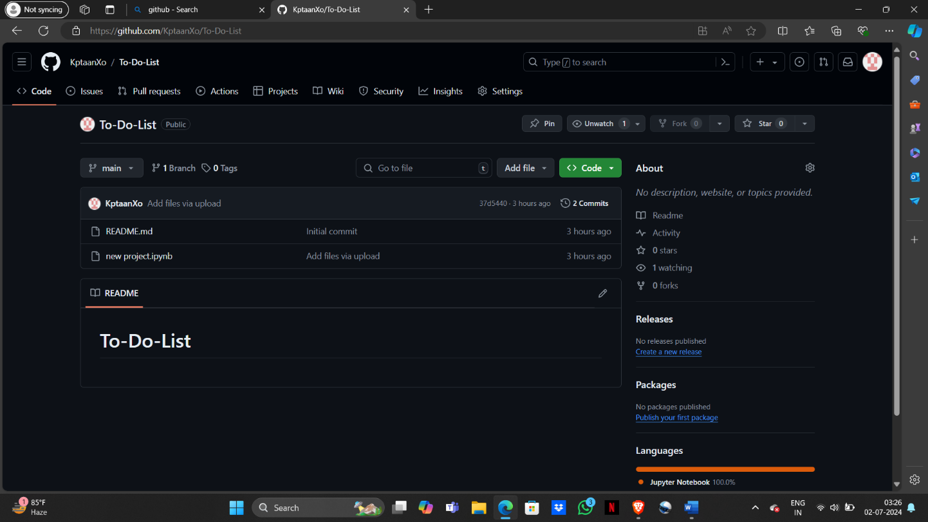

Fig1: screenshot of github

Following Are The Files Uploaded:

* Screenshots: This contains all the output screenshots.
* README.md: The README.md file helps people understand how the to- do list project works and encourages community participation.
* Main.ipynb: This file contains the python script uses Tkinter to construct a desktop application for managing tasks with user authentication and database integration via MySQL.
* MYSQL.txt: This contains SQL script that creates a MySQL database called project with two tables: users and tasks.

# SCREENSHOTS:

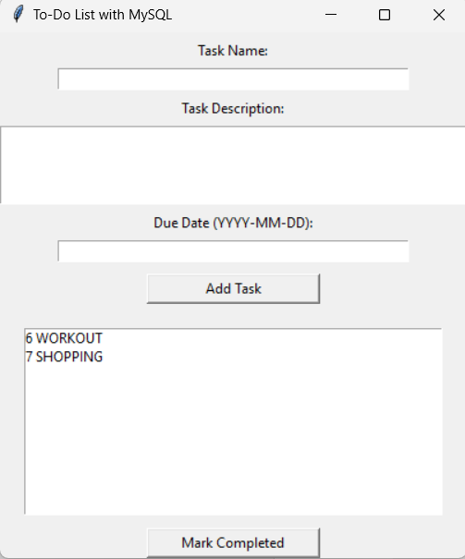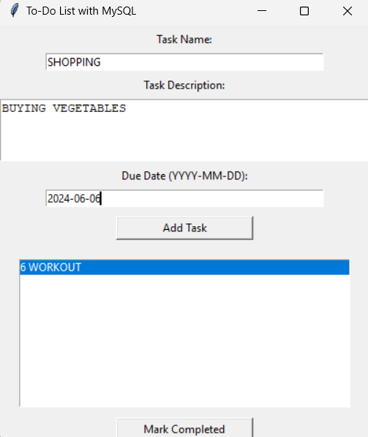

Fig 2: Tasks entered by user Fig3: Task added

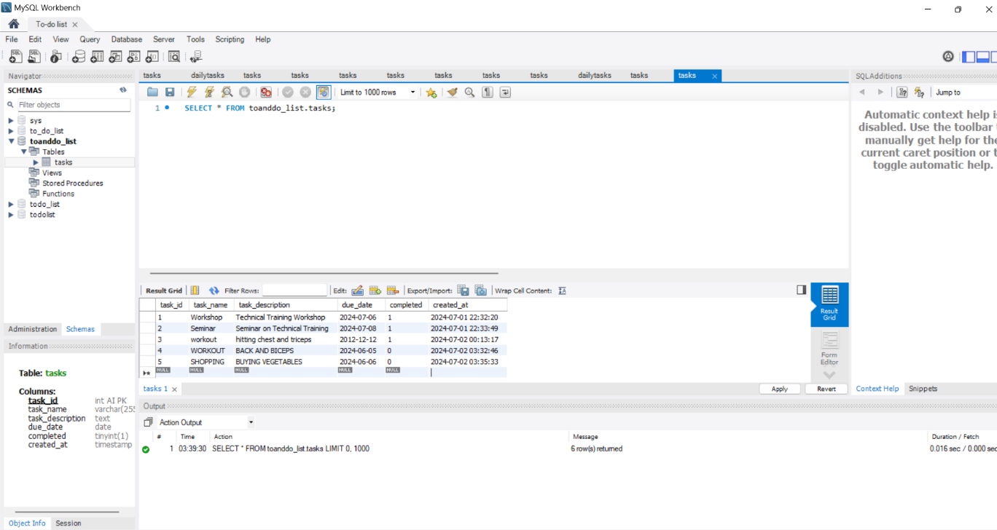

Fig4:table-tasks contains different tasks entered by user